Hello,

Dear high-school friends:

Welcome to NK University.Especially,Welcome to the distinctive NK study trip organized by our team. As your guide,I’m so sure that you will be impressed by this trip. Because in this trip you will enjoy the most famous cultural and natural scenery spots in NK and most importantly you will embark on a trip through history and learn about the story and spirits behind the scenery spots of NK. In this trip,I will take you to the Sculpture of Prime Minister Zhou Enlai firstly, then the Siyuan Hall and Xingsheng Building , lastly we will go to the Horseshoe Lake and if luckily we can see the beautiful lotus that call Mr Ye Jiaying back to her motherland.So let’s get to the point. 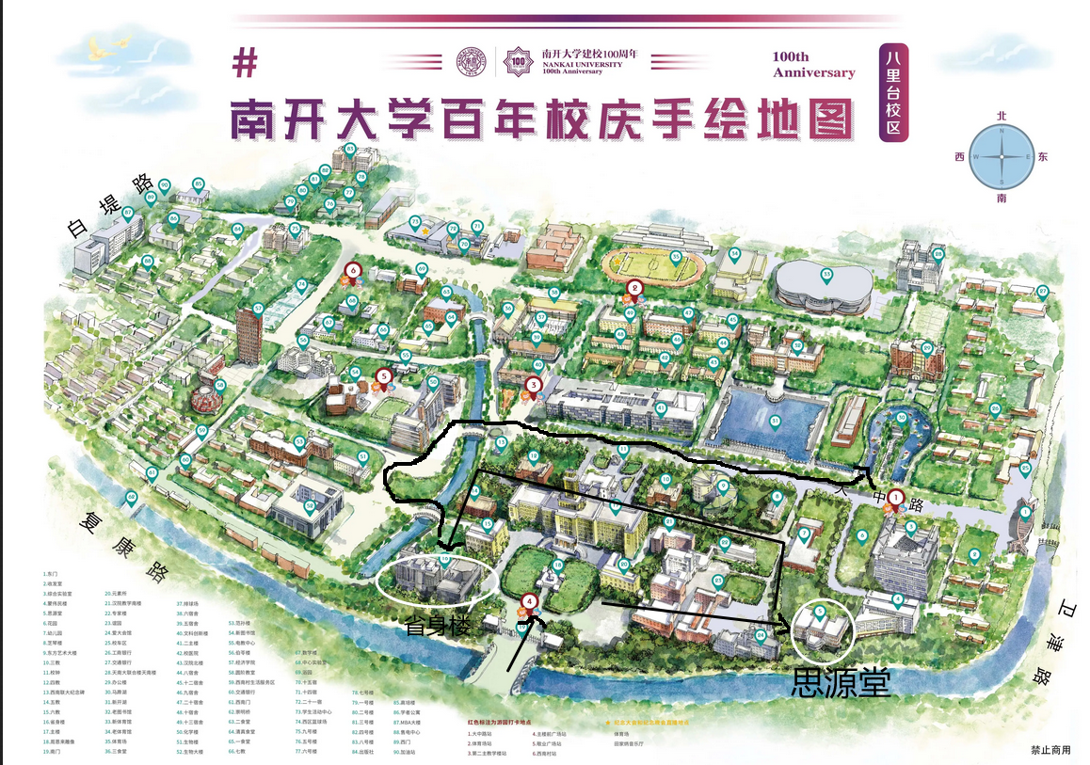

The first stop in the trip through history is the Sculpture of Prime Minister Zhou Enlai.In addition to looking up to the great man,we will watch the story behind the sculpture. Time goes back to 1919.

After the May Fourth Movement broke out in 1919, Zhou Enlai, who had just returned to China from Japan, actively participated in the movement.He edited the Tianjin Student Federation newspaper, founded the student patriotic organization "Awakening Society", and gradually became the leading backbone of the student movement.

On January 23, 1920, members of the Tianjin Student Association investigating Japanese goods found the store hidden Japanese goods didn’t report to the leadership , covered up the cooperation with Japanese, beat students, all of which aroused indignation. People from all walks of life petitioned the provincial government, but the reactionary authorities brutally suppressed them. In order to oppose the the Northern Warlord government's suppression of the students' patriotic movement, Zhou Enlai led more than 5,000 students from various schools in Tianjin petition the Government office , but they were arrested by the military police. The reactionary authorities arrested over 20 representatives ,closed down student federation and associations ,causing a sensational political event.

Since his arrest on January 29, 1920, Zhou Enlai unswervingly believed that there was nothing wrong with students protesting against the government's inaction for the sake of national development and national awakening.

In prison, arrested students went on hunger strikes against the government to declare themselves.In response to the students' struggle, the prosecution allowed their family and friends to visit them, and they can read books and relax in the yard regularly.

“Cease to struggle and you cease to live.”Here, Zhou Enlai organized reading groups and regularly gave lectures to those arrested students.On July 17, the Tianjin District Court held a court session, acquitted those representatives who had been arrested for six months in the prison was released on the spot.

The experience of being in the prison made Zhou Enlai more firm in his ideal of reading for the rise of China.In November of the same year, with the support of Yan Xiu and Liu Chongyou, the founders of Nankai University, Zhou Enlai sailed to France and embarked on a new revolutionary course.

Later, he united and led a large number of progressive in the US and Europe to join the Communist Party of China. The major decisions made and events experienced by the Communist Party of China are closely related to him. After the founding of the People's Republic of China, he also assisted Mao Zedong in leading the all-round construction of the People's Republic of China, and made great efforts in running the Party, state and army, as well as in the fields of internal affairs, national defense and foreign affairs.

The the second stop is the the site of Siyuan Hall. Time goes back to the Anti -Japanese war.

（穿越ing）On July 29, 1937, The Japanese army bombed Nankai University. The Muzhai library with numerous books and the Xiushan Hall, an office building, were both destroyed in the war.An important bell inscribed with the Diamond Sutra on the nankai campus was also towed away by the Japanese.In this event,Nankai suffered countless losses in the disaster

After nankai was bombed, Zhang Boling issued a call to nankai alumni, "You are nankai students,and you have to experience the spirit of Nankai to work hard."(你们是南开的学生，你们得体会着南开的精神努力去干)Although the nankai campus had been destroyed, but the spirit of patriotism of zhang Boling and nankai teachers and students would not die.Since then,they had embarked on a journey of southward migration.

At this time, Nankai University, Tsinghua University and Peking University moved south to form changsha Temporary University.As the anti-Japanese situation in China was increasingly severe, three schools were ready to relocate to Yunnan Province.

There were two main routes for temporary university teachers and students to enter Yunnan.One was that the Hunan-Guizhi-Yunnan tour group, led by Huang Yusheng, went to Kunming on foot,which showed the intrepid spirit of Chinese college students.They camped in wind,overcoming all obstacles on the way.Another route was that the students travelled around by train and boat and finally arrived in Kunming.

In 1938,the temporary university was renamed National Southwest Associated University.During the days in Kunming, nankai students had created a miracle in the history of modern Chinese education with their resolute and persistent spirit, hardworking and optimistic attitude.They showed us what Chinese college students should look like.The southwest Associated University persisted until the victory of the Anti-Japanese War, which enabled China's higher education to continue to sing in the southwest frontier area of China and passed on civilization from generation to generation.From then on, nankai opened a new chapter in its history.

The third stop is the Xingshen Building.Time has come to 1985.

* When the mathematician/ˌmæθəməˈtɪʃn/  Chen xingshen joined Nankai University , Nankai Mathematical Research Institute was established. And at this time it’s so lucky of you to attend Mr.Chen’s lecture which covers numerous/ˈnuːmərəs/  areas of mathematics. We’re sure that you will spend the best hours in your lives with him and you will be amazed by the charm of his personality which creates good memories for you and your math learning. Through the observation of the part of math, you may recognize the whole university of rigorous /ˈrɪɡərəs/  style of study and research.

The last stop in the trip through history is the HorseShoe Lake and Jialing school.

* Back to reality，we also prepare a meaningful activity for you.You will have a chance to appreciate the charming of poetry.A lecture given by a person selected to moving China will be held in the last stop of this trip,jialing academy /əˈkædəmi/ , a modern building with a style of ancient China . you can guess who is she，yes，it is Ye Jiaying .You can communicate with her face to face, feeling the ancient literati  /ˌlɪtəˈrɑːti/ temperament in her. In the process,you may recreate the beauty of the poetry .She will talk about poetry, literature,and her story about nankai for 1hour .then you can ask a question to her.Through the process of this lecture ,you can definitely feel the profound humanistic/ˌhjuːməˈnɪstɪk/ heritage of this university and the beauty of traditional Chinese culture.

Arriving here,our trip through history is almost over.In this trip,our team just want to ,by visiting scenic spots, explore the history behind them and feel the patriotic spirit of NK people all the time, and I believe that is also what inspires generations of Nankai people to work harder and harder. All in all, the purpose of our journey is to hope that you will fall in love with Nankai,and that’s the meaning of our struggle.At last,welcome to NK.Thank you.